**1.5 C++ VARIABLES & CONSTANTS**

Any program processes data. They are located in the computer's RAM, and can be **variable** (the value of the date can change) or **constant** (the value cannot change).

**Variables**

A **variable** represents a memory location where a value of a particular **type** resides. Any variable is characterized by:

* the address of the variable. Computer RAM is addressable – each byte in memory has a sequence number associated with it, starting at 0. This number represents the address of that byte and is displayed in base 16 by default.
* variable identifier - represents a name for the variable - the connection between the variable and its address. The identifier complies with the following rules:
* contains uppercase, lowercase letters of the English alphabet, numbers and the underline character '_'. Uppercase letters are considered different from lowercase letters, so Answer, Answer, and ANSWER are different identifiers.
* the first character cannot be a number. Although it is possible for an identifier to start with '_', it is not recommended to avoid certain conflicts with system identifiers.
* identifier cannot be part of the list of reserved words - available at the end of this article.
* there are no limits on the length of an identifier, but only the first 31 characters are significant.
* the type of the variable – determines what kind of values ​​the variable can take, between which limits they are, as well as what operations can be performed with the variable.
* visibility area – represents the area in the program where the variable exists and can be used. Variables can be global or local.
* local variables are declared within a block (in curly braces {...}) and are only visible within that block. They have random initial values.
* global variables are declared outside any block and are visible in all blocks following the declaration. They are initialized to 0.

In C/C++, variables must be declared, specifying the type and identifier. The syntax is:

*Data_type List_identifiers;*

where *Data_type* can be any valid C++ type (read here about data types), and List_*identifier* consists of at least one identifier. If there are more, they will be separated by the comma character (,).

e.g.:

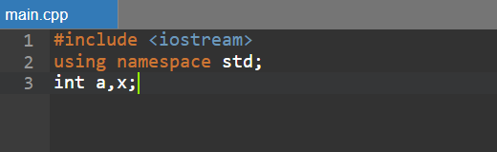

Two variables have been declared, named a and x, which will be able to store integer values ​​from a range that we will study later. When declaring, variables can be initialized with a value corresponding to the data type used:

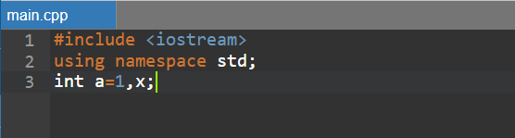

The following C++ identifiers are valid: *a, number, Number, other_number, a2b, _amount -* not recommended*, a very_long_variable_name*.

The following C++ identifiers are incorrect:

* *2a* – starts with number. Identifiers can start with letters or '_'
* *other number* – contains prohibited character: space
* *one-number* - contains forbidden character: minus
* *number* – contains the letter ă. Identifiers can only contain ASCII letters – from the English alphabet.

**Constants**

Constants are data that **do not change** their value during program execution. They can be **constants with name**, or **literal constants**, given directly by their value.

**Symbolic constants**

Symbolic (named) constants can be specified in two ways:

* by the *define* directive
* variables can be declared with the *const* modifier; they become read-only, and their value **can no longer be modified**

e.g.:

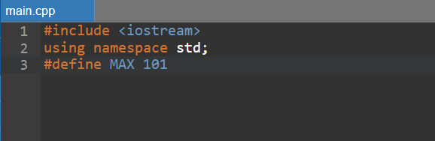

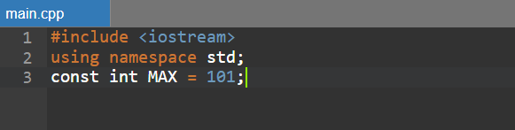

**Literals**

Constant values ​​can appear in a program, whether they are numbers, characters, strings, or otherwise. These are also called **literal constants** or **literals**.

**Integer constants**

Represent whole numbers – with no fractional part. May be:

* Decimal constants – in base 10:
* examples: 176, -54, 0;
* can contain the digits: 0 1 2 3 4 5 6 7 8 9;
* Octal constants – in base 8
* always start with 0;
* examples: 015, 062;
* can contain the digits: 0 1 2 3 4 5 6 7;
* Hexadecimal constants – in base 16:
* always start with 0x;
* examples: 0x15, 0x6f, 0xff;
* may contain the digits: 0 1 2 3 4 5 6 7 8 9 A B C D E F.

**Real constant**

They represent **real numbers** and are also called **floating point**. The decimal separator is the period character (.) and can appear in two forms:

1. **standard writing** (fixed): -1.5 14,974
2. **scientific notation**, with mantissa and exponent. The number -0.567E+2 means -0.567*10+2, i.e. -56.7:

* -0.567 represents the mantissa;
* +2 represents the exponent.

**Character constant – char**

They are made up of a single character, delimited by apostrophes: (').

e.g.: *'a', 'B', '~', '?'*

A separate category of characters consists of **ESCAPE sequences**. An escape sequence consists of **two characters**, the first of which is the backslash: \. Represents characters that cannot be written as such or have a special meaning. From a syntactic point of view, they are characters, being delimited by an apostrophe. Probably the most well-known escape sequence is **'\n'** – new line (enter).

Among the escape sequences we mention:

* '\n' – Newline
* '\b' – Backspace
* '\f' – Form feed
* '\r' – Return
* '\t' – horizontal TAB
* '\\' – Backslash
* ''' – Apostrophe
* '\"' – Quotation marks
* '\?' – Question mark
* '\0' - Null character

**String constants**

They are delimited by quotation marks ("). May contain **escape sequences**.

e.g.: *"number", "n = ", "I'm done.\n"*

**Pay attention to!**

* Initialization is mandatory when declaring *read-only* variables!
* An octal constant cannot contain the digit 9. The value 0295 is not correct and will produce a compile error!
* A char constant contains exactly one character. We can't have multiple characters between apostrophes, except for escape sequences, but an escape sequence is only one character!
* 'A' and "A" are not the same thing: 'A' is a character, and "A" is a string, consisting of a single character!

**Reserved words**

Not every word can be used as an identifier. There is **a list of words** in C++ that have a well-defined meaning and cannot be used for any other purpose. They are called reserved words (keywords) and are as follows:

|  |  |  |
| --- | --- | --- |
| **alignas alignof and and_eq asm auto bitand bitor bool break case catch char char16_t char32_t class compl concept const constexpr const_cast continue decltype default delete do double dynamic_cast** | **else enum explicit export extern false float for friend goto if inline int long mutable namespace new noexcept not not_eq nullptr operator or or_eq private protected public register reinterpret_cast** | **requires return short signed sizeof static static_assert static_cast struct switch template this thread_local throw true try typedef typeid typename union unsigned using virtual void volatile wchar_t while xor xor_eq** |